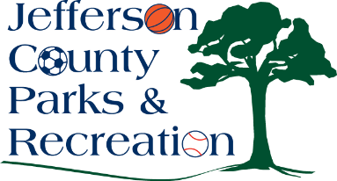
Jefferson County Parks and Recreation Commission
Audit Committee Meeting Agenda
November 13, 2025
6:30 p.m.
JCCC or via Zoom:
Meeting Link: https://us02web.zoom.us/j/86034902140?pwd=BVTQnosOvRY7gExUaDbaD7EAr5MoCZ.1

- Call to Order
- No Previous Meeting Minutes
- Update on 2026 Audit a
- Discussion on MD&A
- Adjourn

