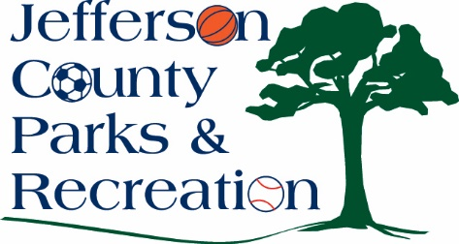
Jefferson County Parks & Recreation Commission
November 19, 2025
7:00 p.m.
AMP Conference Room or Virtual Link:
https://us02web.zoom.us/j/88491859690?pwd=mO0iWnlwTegWXm6UMmu84xOw7fMYat.1

- Call to Order

- Roll Call

- Public Comment

- Approval of Minutes

- Treasurer’s Report

- Director’s Report

VII. Standing Committee Reports
1. Executive
2. Finance
- Approval of October bills.
3. Infrastructure
4. Operations
5. Human Resources
6. Audit

- Old Business

- New Business
  - Discussion and possible action on approval of FY 27 Capital Improvement Plan
  - Discussion and possible action on approval of holiday hours for the 2025 holiday season
  - Discussion and possible action on approval to sell alcoholic beverages at the Golden Gala Adult Prom that will be held in the Jefferson County Community Center on February 21st
  - Discussion and possible action on committee assignments and dates for 2026

XI. Adjournment

