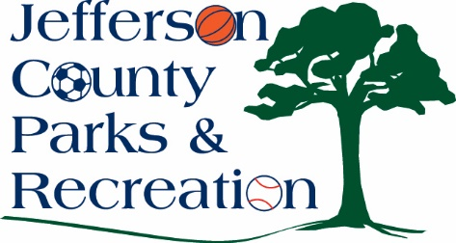
Jefferson County Parks & Recreation Commission
December 10, 2025
6:00 p.m.
Virtual Link:
https://us02web.zoom.us/j/83138339174?pwd=3zEkKXdRHrshBCkI1OwDG8iBWC99jh.1

- Call to Order

- New Business
  - Discussion and possible action of hiring an on-call architectural and engineering firm.
  - Discussion and possible action on approval to submit a Land and Water Conservation Fund Grant application, due in December. Approval of official resolution.
  - Discussion and possible action on sending a letter to American Water and Charles Town Utility Board expressing interest in obtaining information to bring public utilities to James Hite Park.
2. Discussion of committee assignments & meeting schedules for 2026.
3. Update on personnel matters. (Possible executive session)

XI. Adjournment

