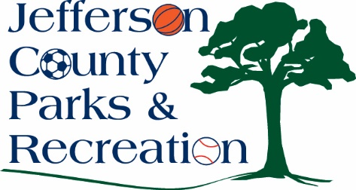
Jefferson County Parks & Recreation Commission
March 18, 2026
7:00 p.m.
AMP Conference Room or Virtual Link:
https://us02web.zoom.us/j/85998485224?pwd=ccGhuRUsAjK1nBV9Y5GQwmkPYy51br.1

.

- Call to Order

- Roll Call

- Public Comment

- Approval of Minutes

- Treasurer’s Report

- Director’s Report

VII. Standing Committee Reports
1. Executive
2. Finance
3. Infrastructure
4. Operations
5. Human Resources
6. Audit

IX. Old Business

X. New Business

- Discussion and possible action on approval of obtaining a letter of support from the County Commission for the Moonshine Festival that will be held in June at Sam Michaels Park.
- Discussion of response and possible action on approval to obtain outside counsel to address a FOIA request regarding refunds.
- Discussion and possible action on approval of a new Recreation Specialist position.
- Discussion and possible action on review of FY 25/26 Audit.

XI. Adjournment

