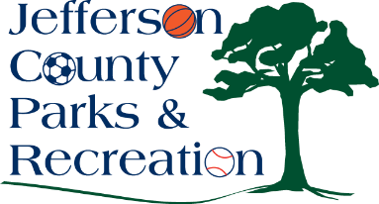
Jefferson County Parks and Recreation Commission
Finance Committee Meeting Agenda
April 14, 2026
5:30 p.m.
https://us02web.zoom.us/j/82452115263?pwd=t952Xd01BAjtouvCEMi52mfoNeB8Qa.1 or AMP Meeting Room

- Call to Order
- Review of FY 25/26 Audit.
- Adjourn

