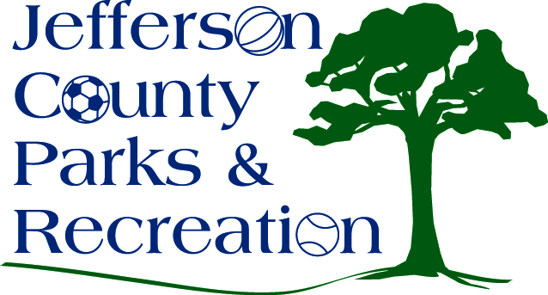
FUNDRAISING COMMITTEE AGENDA
Jefferson County Parks & Recreation Commission
August 13, 2015
3:00 p.m.
Jefferson County Community Center

Old Business:
- Status of 501 3(c) application
- Status of plans for fall work date for children’s and teen groups
- Status of work towards getting local groups to adopt events
- Status of plans/designs for signs for acknowledging donors

New Business:
- Planning for Walmart bake sale Saturday 10/17
- Plans for notifying dog park folks of a move next spring and requesting their assistance in raising funds for the fencing for the dog park at James Hite Park
- Potential dog-related fundraiser
- Planning for January Bingo Blitz fundraiser/also potential April date
- Planning for Jim Lee’s race in October
- Changing the fundraising committee meeting time starting in Sept.

