Executive Committee Agenda
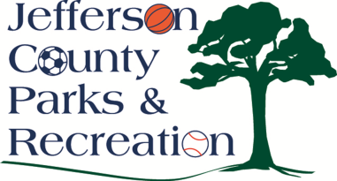
Monday, September 14, 2015
6:00 p.m.
Jefferson County Community Center

  - Update on Corbin Benefits
  - Discussion on update to Employee Benefits to coincide with the County Commission
  - Discussion on grant opportunities this fall for capital projects
  - Discussion on James Hite Park expenditures
  - Discussion on Development & Special Events Coordinator position

