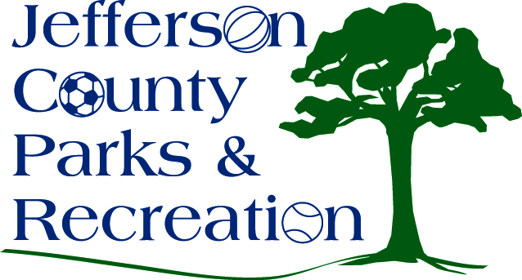
SPECIAL MEETING AGENDA
Jefferson County Parks & Recreation Commission
September 16, 2015
7:00 p.m.
Jefferson County Community Center

- Call to Order

- Unfinished Business
  - Discussion and Possible Action on approval of monies from the Capital account for completion of James Hite Park.
  - Discussion and Possible Action on information received from the Public Employees Insurance Agency concerning insurance benefits for past employees. (Possible Executive Session)

- Old Business

- New Business
  - Discussion and possible action on a Development & Special Events Coordinator position.
  - Dicussion and possible action on changes to employee handbook regarding absence time with pay
  - Discussion and possible action on providing match with Summit Point Babe Ruth Baseball to place a flag pole at South Jefferson Park.
  - Discussion and possible action on 2016 Fireworks Event

