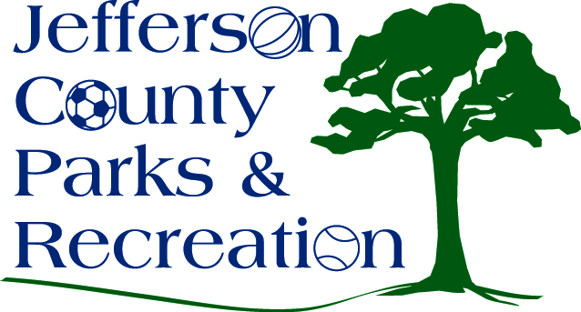
AGENDA
Jefferson County Parks & Recreation Commission
October 21, 2015
7:00 p.m.
Jefferson County Community Center

- Call to Order

- Roll Call

- Public Comment

- Approval of Minutes

- Treasurer’s Report

- Director’s Report

- Standing Committee Reports

      - Executive

      - Finance

      - Facilities/Land Acquisition

- Unfinished Business
  - Discussion and possible action on a Development & Special Events Coordinator position and job description.
  - Discussion and possible action on 2016 Fireworks Event

- Old Business

- New Business

      - Christmas Party

