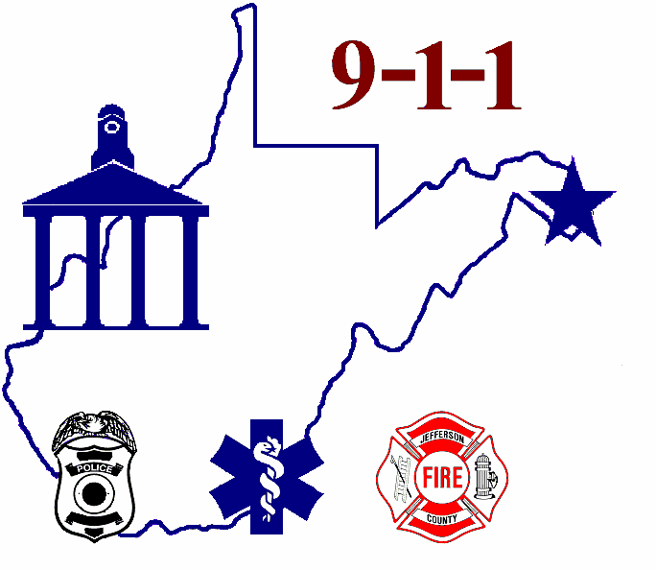
Jefferson County
Emergency Communications Center

28 Industrial Boulevard, Suite 100
Kearneysville, WV, 25430-9425
Phone: 304-725-8484 • Fax: 304-728-0779

Supplemental Questionnaire

Date of Application:

Position Applied For:

Name:
Last First Middle

Are you a Veteran of the U.S. Military Service: ___ Yes ___ No

Indicate languages you speak, read and/or write:

 | FLUENT | GOOD | FAIR
Speak
Read
Write

Special Employment Notice to Disabled Veterans, Vietnam era Veterans, and individuals with physical or mental handicaps.
Government contractors are subject to 38 USC 2012 of the Vietnam Era Veterans Readjustment Act of 1974 which requires that they take affirmative action to employ and advance in employment, qualified disabled veterans and veterans of the Vietnam Era, and section 503 of the Rehabilitation Act of 1973, as amended, which requires government contractors to take affirmative action to employ and advance in employment qualified handicapped individuals.
If you are a disabled veteran, or have a physical or mental handicap, you are invited to volunteer this information. The purpose is to information regarding proper placement and appropriate accommodation to enable you to perform the job to the best of your ability in a in a proper and safe manner. This information will be treated as confidential. Failure to provide this information will not jeopardize or adversely affect your consideration for employment If you wish to be identified, please sign below.

___ Handicapped Individual ___ Disabled Veteran ___ Vietnam Era Veteran

VOLUNTEER EXPERIENCE

Job related community or volunteer experience (if applicable). Do not list any political affiliations.

Dates Organization

Special Responsibilities
Dates Organization

Special Responsibilities

CONVICTIONS

Have you ever been convicted of a felony or misdemeanor or been on parole or probation? Yes ____ No ____

If yes, please explain fully. Attach a separate sheet of paper if this space is not adequate. List all convictions after your 18th birthday. (A “yes” answer is not an automatic bar to employment. Each case is considered individually.)

If you need additional space please continue on a separate sheet of paper.

SPECIAL SKILLS and QUALIFICATIONS

Summarize special skills and qualifications acquired from employment or other experience:

Describe Specialized Training, Apprenticeship, Skills, and Extra-Curricular Activities:

Citizenship or immigration status will be required upon employment. Can you provide proof of identity and the legal ability as a U.S. Citizen or lawfully authorized alien to work in the U.S.? ____ Yes ____No
(Proof of citizenship will be required upon employment.)

Have you ever received any vehicle citations for moving violations within the last 5 years? Yes _____ No (A “yes” answer to this question is not an automatic bar to employment. Each case is considered individually for positions requiring a valid West Virginia Drivers License.)

If yes, please explain fully. (Attach a separate sheet if this space is not adequate.)

When would you be available to begin work?

Signature: Date:

